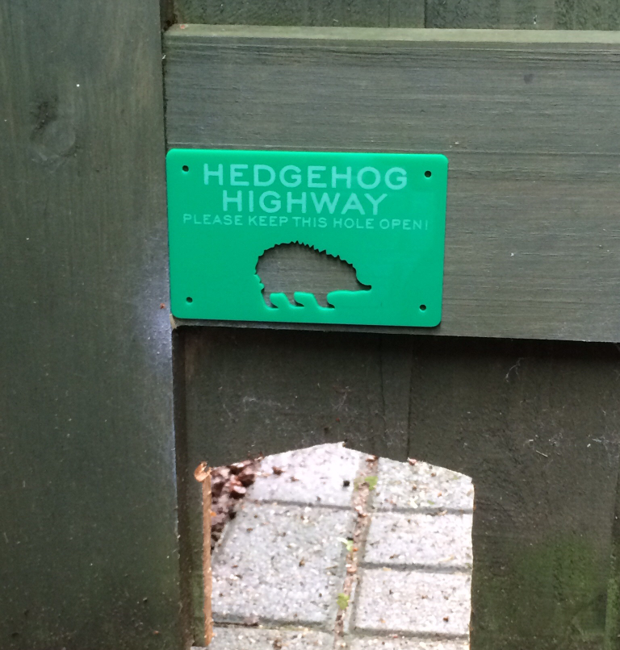
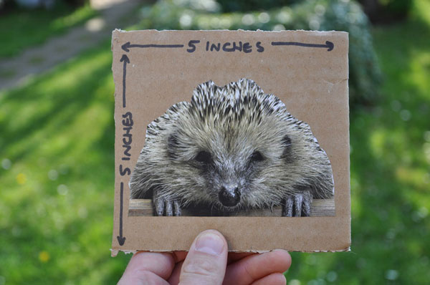
How many gardens in your road
can you link to help hedgehogs?
Let's link our gardens to help
Save our Hedgehogs

Hedgehogs need to visit many gardens every night to find enough food, but modern fences block
their way. Let's help them by making hedgehog holes in fences.

We can all help save hedgehogs
Just cut out a hole 13cm by 13cm
(5 x 5 inches) in a fence or wall.

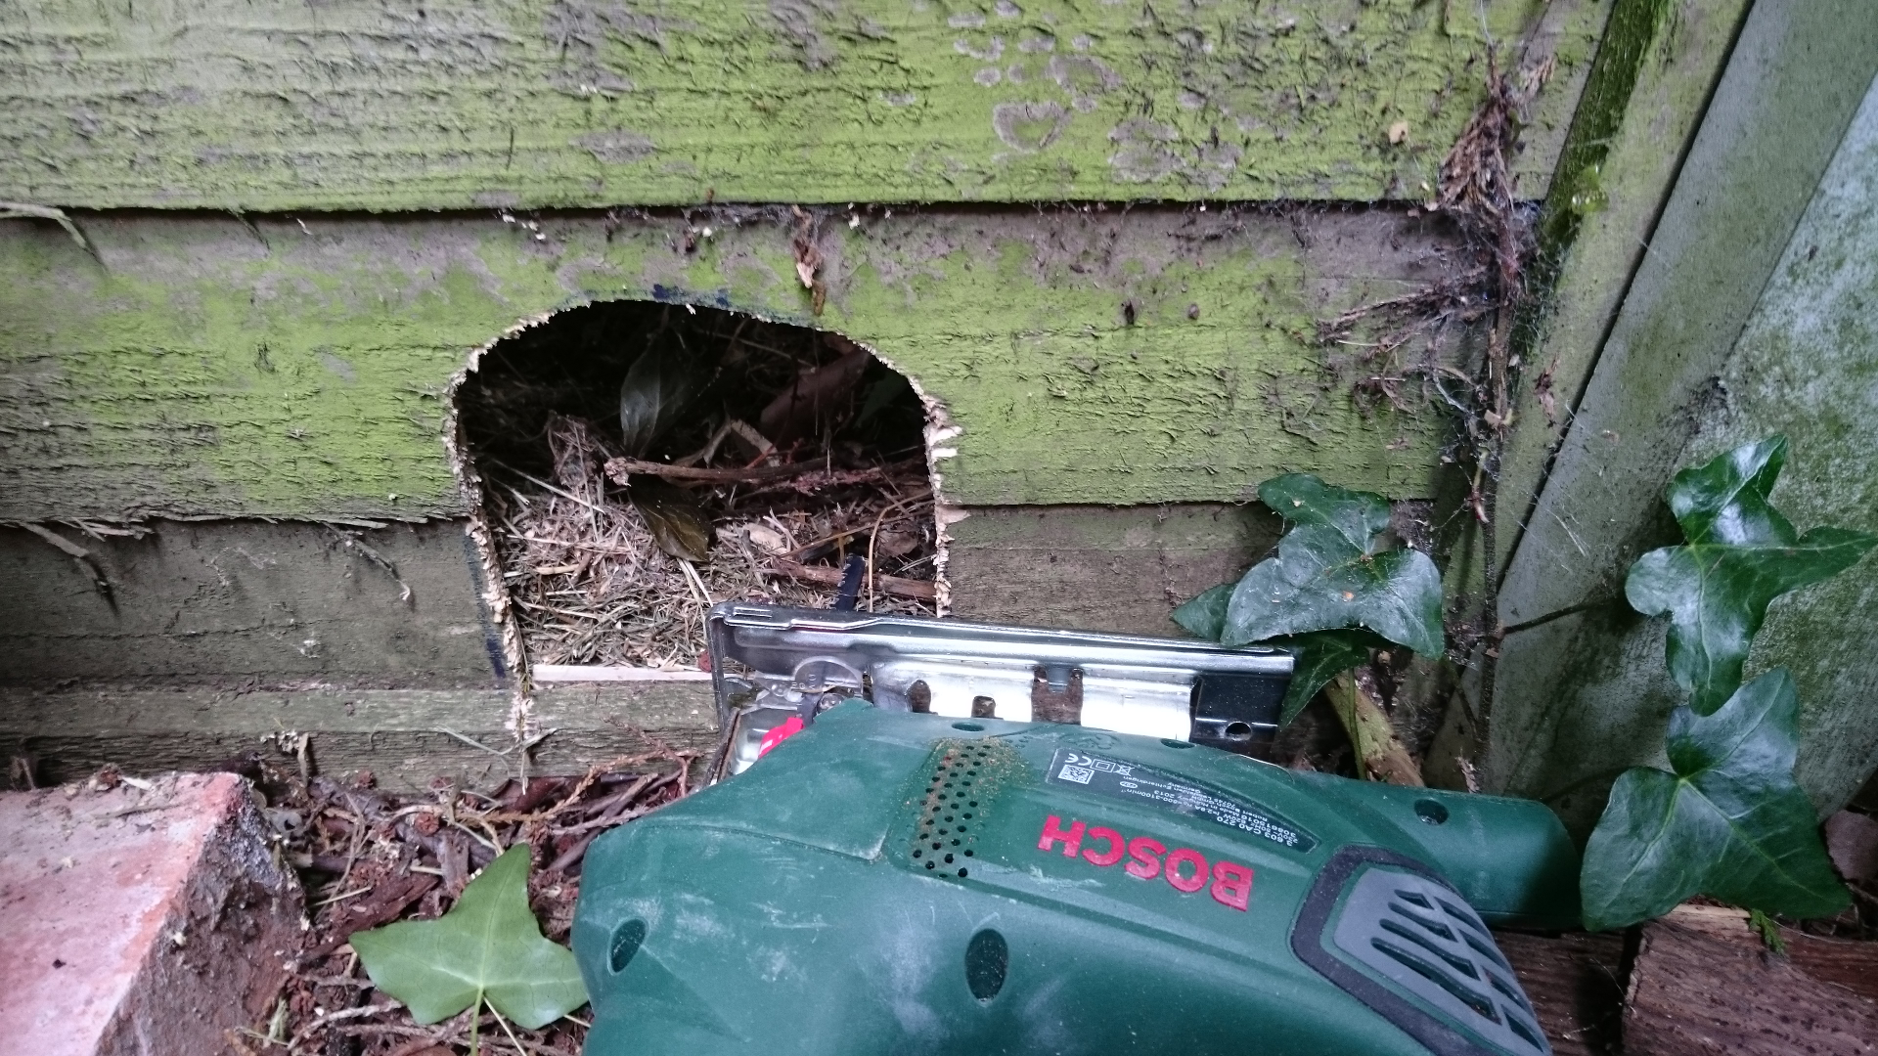
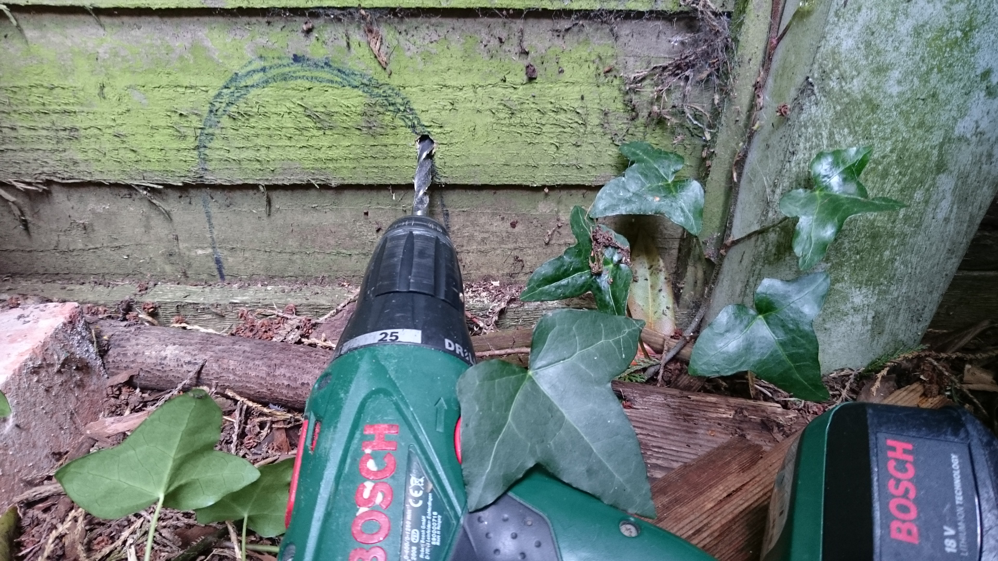
How many gardens in your road
can you link to help hedgehogs?
You can find more information about hedgehog holes and how to buy “Hedgehog Highway” signs by searching online. You should always check with your neighbour(s) and property owners before making holes in fences. Only undertake work if you have permission and are competent to do it, and always take safety precautions. If in doubt seek expert advice. Leaflet copyright © 2018 Gareth Randall (gareth@garethrandall.com). Photo credits:
1. Front top photo by kind permission of Jason Alexander wildlifegadgetman.com, 2. Front lower photo credit “Pam Lovesay, Hedgehog Champion”, 3. Background photo credit “Claim To Fame Man [CC0], from Wikimedia Commons”. See: https://commons.wikimedia.org/wiki/File:Hedgehog_2..JPG , 4. Back photos credit “David Orme, Hedgehog Champion”
Hedgehogs help our gardens

Hedgehogs help gardens by:
- Eating slugs and insect pests.
- Providing droppings which act as natural fertiliser and bring nutrients.

Hedgehogs roam between 1-2km each night during their active season.

Most pets are too small to fit through hedgehog holes. If you are concerned then add a tunnel leading to the hole, keeping to the minimum size of 13cm x 13cm (5 x 5 inches), to deter cats and other larger animals.

Other things you can do to help:
- Make your pond safe. Ensure hedgehogs can climb out if they fall in. Add a pile of stones, a piece of wood or some chicken wire to create a simple ramp.
- Tidy away netting and litter to prevent hedgehogs from getting tangled.
- Stop using chemicals, because lawn treatments reduce the worm populations which hedgehogs eat.

